Configuring SQL Server 2000 for Security Logger

Purpose
The purpose of this document is to describe the steps necessary to configure SQL Server 2000 for Security Logger. The document is divided in to four sections: Importing the Databases, Adjusting the Database Design, Creating a SQL User and Creating the DSNs.

This document assumes that you have some basic knowledge of how to connect to an SQL 2000 Server through the Enterprise Manager.

Importing the Databases
Security Logger writes records to two databases: TrafficLog and MessageLog. When the product is first installed, an Microsoft Access version of these databases are placed in the <INSTALL DIRECTORY>\Data folder (by default the C:\Program Files\SecurityLogger\Data folder). You will need to import these databases to SQL Server 2000.

Importing the TrafficLog.MDB Database
Complete the following steps to import the TrafficLog.MDB database to SQL Server 2000.
- Connect to the SQL server through the Enterprise Manager.
- In the Enterprise Manager, go down the tree to find the SQL server that will be housing the databases.
- Under the server, highlight the Databases folder, right mouse click and go to New Database….
- In the Database Properties window General tab, type in the database name TrafficLog. Click on OK to create the new database.
- Under the Databases folder, you should see a new database called TrafficLog. Highlight TrafficLog, right mouse click and go to All Tasks -> Import Data…. This will bring up the DTS Import/Export Wizard.
- In the DTS Import/Export Wizard window click on Next.
- In the Choose a Data Source window, use the pull down next to Data Source: to select Microsoft Access. Click on the … button next to File Name: to select the TrafficLog.MDB file. Click on Next.
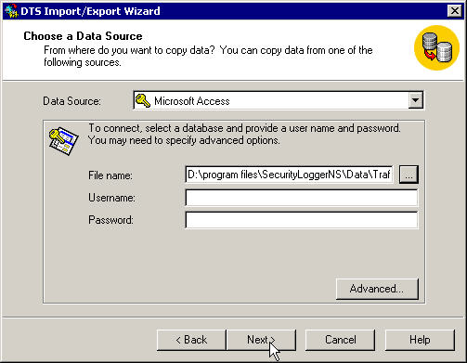
- In the Choose a Destination window, accept the defaults and click on Next.
- In the Specify Table Copy or Query window, accept the defaults and click on Next.
- In the Select Source Tables and Views window click on Select All. Click on Next.
- In the Save, Schedule and Replicate window, verify that Run immediately is selected. Click on Next.
- In the Completing DTS Import/Export click on the Finish button.

Importing the MessageLog.MDB Database
Complete the following steps to import the MessageLog.MDB database to SQL Server 2000.

- Connect to the SQL server through the Enterprise Manager.
- In the Enterprise Manager, go down the tree to find the SQL server that will be housing the databases.
- Under the server, highlight the Databases folder, right mouse click and go to New Database….
- In the Database Properties window General tab, type in the database name MessageLog. Click on OK to create the new database.
- Under the Databases folder, you should see a new database called TrafficLog. Highlight MessageLog, right mouse click and go to All Tasks -> Import Data…. This will bring up the DTS Import/Export Wizard.
- In the DTS Import/Export Wizard window click on Next.
- In the Choose a Data Source window, use the pull down next to Data Source: to select Microsoft Access. Click on the … button next to File Name: to select the MessageLog.MDB file. Click on Next.
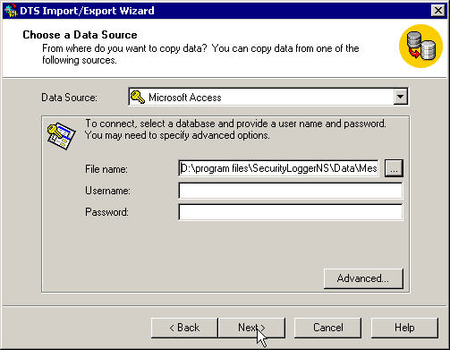
- In the Choose a Destination window, accept the defaults and click on Next.
- In the Specify Table Copy or Query window, accept the defaults and click on Next.
- In the Select Source Tables and Views window click on Select All. Click on Next.
- In the Save, Schedule and Replicate window, verify that Run immediately is selected. Click on Next.
- In the Completing DTS Import/Export click on the Finish button.

Adjusting the Database Design
SQL Server 2000 makes some assumptions when importing a Microsoft Access databases. These assumptions are not correct for the databases. To correct these assumptions, complete the following steps.

Adjusting the TrafficLog Tables
The following steps describe how to adjust the tables in the TrafficLog database. All of these tables can be found by traversing the tree in Enterprise Manager. The tables are in the Databases -> TrafficLog folder under Tables. The tables that need to be adjusted are the Counters, Firewall, FQDN, SERVICE and Traffic.

- Highlight the Counters table, right mouse click and go to Design Table.
- Highlight the ID field and click on the Set primary key icon (key icon).
- Click on the Identity line under the columns tab. A pull down option will pop up. Use the pull down to select Yes. The Identity Seed and Identity Increment lines will be filled in for you.
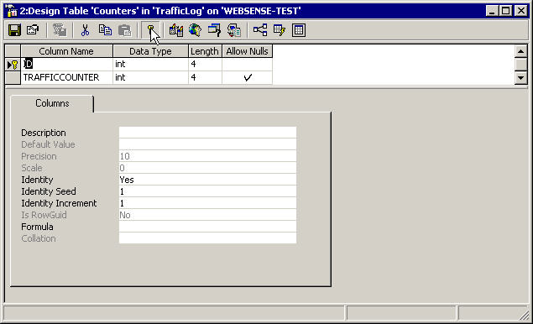
- Click on the close window button. When prompted, save the changes to the Counters table.
- Complete steps 1 through 4 for the Firewall, FQDN and SERVICE tables.
- Highlight the Traffic table, right mouse click and go to Design Table.
- Highlight the ID field and click on the Set primary key icon (key icon).
- Click on the Identity line under the columns tab. A pull down option will pop up. Use the pull down to select Yes. The Identity Seed and Identity Increment lines will be filled in for you.
- Scroll down the Column Name field and locate the column “DATE”.
- In the Data Type field for the Column Name “DATE” change the type from smalldatetime to datetime.
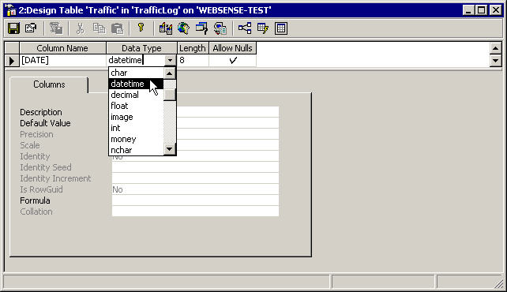
- Complete steps 9 and 10 for the field START_DATE.
- Close the window. When prompted, select to save the configuration changes.

Adjusting the MessageLog Tables
The following steps describe how to adjust the tables in the MessageLog database. All of these tables can be found by traversing the tree in Enterprise Manager. The tables are in the Databases -> MessageLog folder under Tables. The tables that need to be adjusted are the Counters and Message.

- Highlight the Counters table, right mouse click and go to Design Table.
- Highlight the ID field and click on the Set primary key icon (key icon).
- Click on the Identity line under the columns tab. A pull down option will pop up. Use the pull down to select Yes. The Identity Seed and Identity Increment lines will be filled in for you.
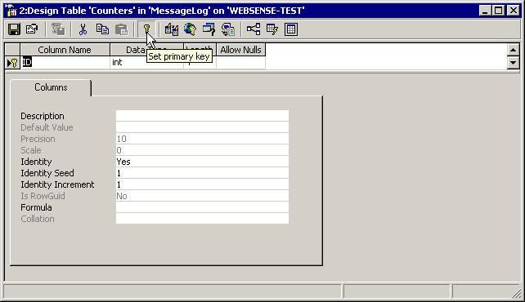
- Click on the close window button. When prompted, save the changes to the Counters table.
- Highlight the Message table, right mouse click and go to Design Table.
- Highlight the ID field and click on the Set primary key icon (key icon).
- Click on the Identity line under the columns tab. A pull down option will pop up. Use the pull down to select Yes. The Identity Seed and Identity Increment lines will be filled in for you.
- Scroll down the Column Name field and locate the column “DATE”.
- In the Data Type field for the Column Name “DATE” change the type from smalldatetime to datetime.
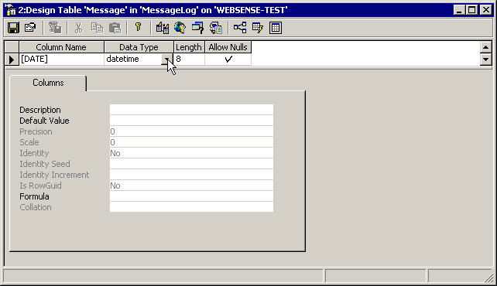
- Close the window. When prompted, select to save the configuration changes.

Creating a SQL User
The following steps describe how to create a SQL user for Security Logger.

- In the Enterprise Manager under the Security folder, highlight Logins. Right mouse click and go to New Login….
- Under the General tab make the following changes/additions:
Name: SLogger
Authentication: SQL Server Authentication
Password: SLogger

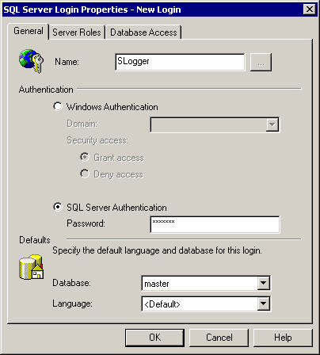
- Under the Database Access tab, click the check boxes next to the MessageLog and TrafficLog databases.
- In the Permit in Database Role section, select db_owner for both the TrafficLog and MessageLog databases.
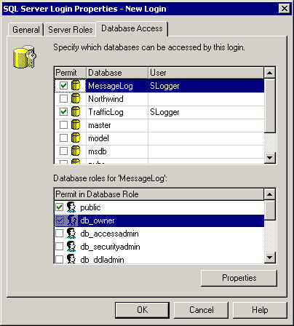
- Click on OK.

Creating the DSNs
Security Logger uses two User DSNs to communicate with the databases. By default these DSNs point to the Access databases in the <INSTALL DIRECTORY>\Data folder. In order to make Security Logger work with SQL, we need to change these DSNs to point to the SQL databases.

These DSNs need to be defined on the machine that will be running the Security Logger application.

The DSN settings can be found by going to My Computer -> Control Panel -> Administrative Tools -> Data Sources (ODBC) for Windows 2000. On machines that are not running Windows 2000, the settings can be found by going to My Computer->Control Panel->Data Sources (ODBC).

Adjusting the Traffic_DB User DSN
To change the Traffic_DB DSN to point to the SQL database instead of the Access database, complete the following steps.

- In the User DSN tab, find the DSN Traffic_DB. Highlight it and click on Remove.
- Click on the Add button.
- In the Create New Data Source window, use the pull down to select SQL Server. Click on Finish.
- In the Create a New Data Source to SQL Server window, put Traffic_DB in the Name: field. In the “Which SQL Server do you want to connect to?” dialog, type in the IP address of your SQL server. Click on Next.
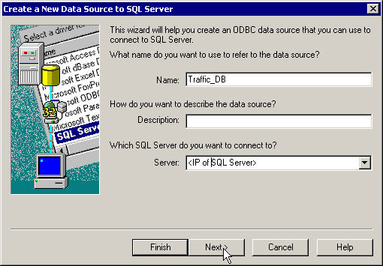
- In the Create a New Data Source to SQL Server window, under the “How should SQL server verify the authenticity of the login ID?” section, select “With SQL server authentication using a login ID and password entered by the user.
- In the Login ID and Password section, enter the login ID of SLogger with a password of SLogger. Click on Next.
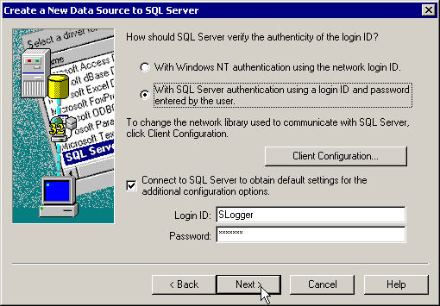
- In the Create a New Data Source to SQL Server window, select the check box next to “Change the default database to:”. Use the pull down to select TrafficLog and click on Next.
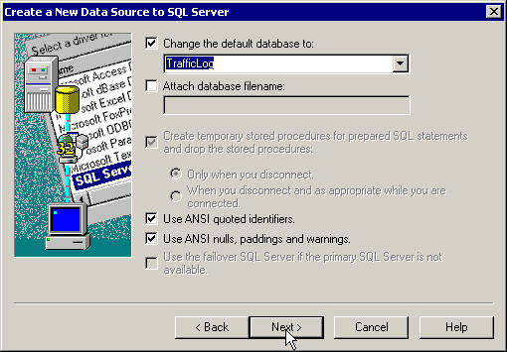
- In the last window click on Finish.
- In the ODBC Microsoft SQL Server setup window click on OK.

Adjusting the Traffic_DB User DSN
To change the Message_DB DSN to point to the SQL database instead of the Access database, complete the following steps.

- In the User DSN tab, find the DSN Message_DB. Highlight it and click on Remove.
- Click on the Add button.
- In the Create New Data Source window, use the pull down to select SQL Server. Click on Finish.
- In the Create a New Data Source to SQL Server window, put Message_DB in the Name: field. In the “Which SQL Server do you want to connect to?” dialog, type in the IP address of your SQL server. Click on Next.
- In the Create a New Data Source to SQL Server window, under the “How should SQL server verify the authenticity of the login ID?” section, select “With SQL server authentication using a login ID and password entered by the user.
- In the Login ID and Password section, enter the login ID of SLogger with a password of SLogger. Click on Next.
- In the Create a New Data Source to SQL Server window, select the check box next to “Change the default database to:”. Use the pull down to select MessageLog and click on Next.
- In the last window click on Finish.
- In the ODBC Microsoft SQL Server setup window click on OK.

