^{Security Log Viewer Access}

Welcome to Security Log Viewer
Getting Started
Main Screen
Commands
File menu
View menu
Help menu

Welcome to Security Log Viewer

Security Log Viewer for Netscreen is a program that allows you to view data collected by the Security Logger program. The data is summarized and can be viewed and sorted in table or graph format. Selecting a variety of filters can further summarize the tables and graphs.
Security Logger for Netscreen is a SYSLOG server that collects SYSLOG messages from a Netscreen firewall. These messages are then sorted in to two classifications, traffic records or message records and written to Microsoft Access databases.

Getting Started

Thank you for evaluating Security Log Viewer for Netscreen.

The product can be installed on the same machine as the Security Logger application or on a different machine. If the program is installed on the same machine as the Security Logger application, then no further configuration changes are needed. If the program is installed on a separate machine, then there are a few steps you need to do to allow the Security Log Viewer application to access the databases.

The first step is to make sure that the machine that is running the Security Log Viewer application has access to the databases. The Security Logger application stores data in to two Access databases. These databases are the TrafficDB.mdb and the MessageDB.mdb files located in the <INSTALLDIR>\Data folder. Once you have access to these databases, you will need to create two User DSNs that point to these databases.

To create the User DSNs, go to My Computer->Control Panel->Administrative Tools->Data Sources (ODBC). This will be in My Computer->Control Panel->Data Sources (ODBC) in non-Windows 2000 systems. Once you have you have opened the Data Sources (ODBC) window, make sure you are in the User DSN tab. Click on the Add… button to create a new User DSN.

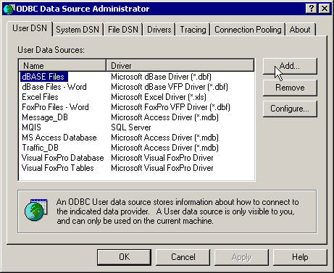

This will bring up the Create New Data Source window. Select Microsoft Access Driver (*.mdb) and click on the Finish button.

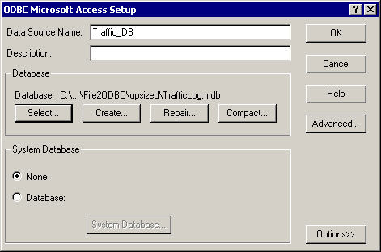

In the ODBC Microsoft Access Setup window type in the Data Source Name of Traffic_DB. In the Database section, select the TrafficLog.mdb file. When finished click on OK. You will need to repeat these steps for the Message_DB DSN and point it to the MessageLog.mdb file.
Main Screen

The main screen of the application lists the set of message records stored in the database. These records can be filtered by firewall IP, date/time, and/or message type. Once you have chosen a set of filters (or none at all), click on the Refresh button to view the results. The results will be displayed in a table.

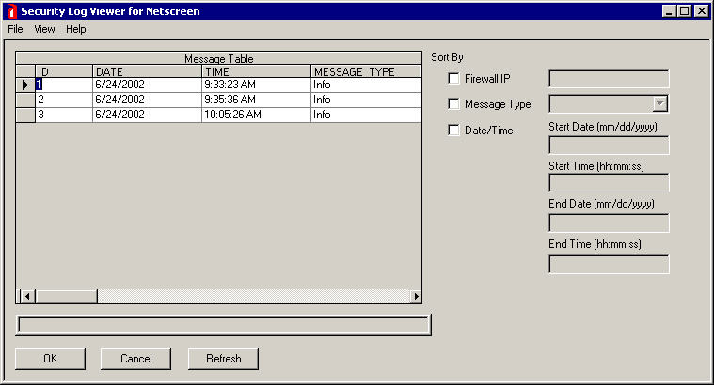

Sort By Firewall IP: This filter allows you to choose to view message records for a specific firewall. If you do not select this option, message records will be displayed for all firewalls.

Sort By Message Type: This filter allows you to choose to view message records for specific message types. Message types are categorized as Alert, Critical, Emergency, Error, Info, Notice or Warning. The message type for each Netscreen specific message can be found in the Netscreen document “Msg_3.0.0.pdf”.

Sort By Date/Time: This filter allows you to choose to view message records that occurred between a specific date and time. The time is in 24-hour time format.

File menu commands

The File menu offers the following commands:

Save Configuration | Saves the current Security Logger configuration.
Exit | Exits the Security Logger application.

View menu commands

The View menu offers the following commands:

View Overall Table | View records in table format.
View Top 10 Graph | Views top 10 in graph format.
View Top 10 Table | Views top 10 in table format.

Help menu commands

The Help menu offers the following commands, which provide you assistance with this application:

Help Topics | Offers you an index to topics on which you can get help.
About | Displays the version number and license status of Security  Logger.
License Update | Updates the license status from evaluation to a full license.

Save Configuration command (File menu)

Use this command to save the current configuration of Security Log Viewer. The saved information includes the various filter options.
Exit command (File menu)

Use this command to end your Security Log Viewer session.

View Overall Table command (View menu)

Lets you view record data in a table format. You can use the filter options if you only want to view a subset of the data.
Once you have chosen the filters (if any), click on the Refresh button to view the results.

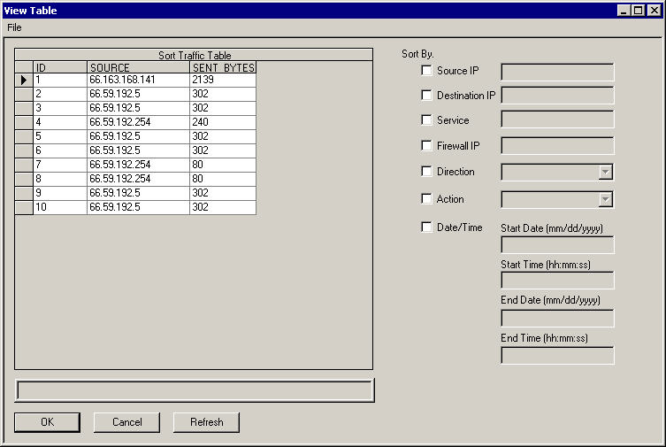

Sort By Source IP: Allows you to filter records by a specific source IP address.
Sort By Destination IP: Allows you to filter records by a specific destination IP address.
Sort By Service: Allows you to filter records by a specific service. Services are in name format (I.E. http, dns, etc.).
Sort By Firewall IP: Allows you to filter records by a specific firewall IP address.
Sort By Direction: Allows you to filter records by a specific direction. These include incoming, outgoing, todmz, fromdmz and to-self.
Sort By Action: Allows you to filter records by a specific action. An action can be permit or deny.
Sort By Date/Time: Allows you to filter records by a specific date/time period. Time is in 24-hour format.

Once the data is displayed in the table, you can export it to file. To do so click on the File->Export menu option.
Type in the destination file, select the format (CSV or Tab Delimited) and click on the Export button.
The export status will be displayed in the status window.

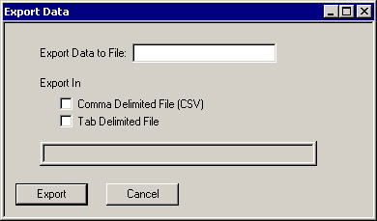

View Top 10 Graph command (View menu)

Lets you view the top 10 in graph format. The top 10 can be defined by using the filters.
The results will be displayed in a graph. The graph totals are displayed in a table.
When you have selected the desired filters, click on the Refresh button to display the results.

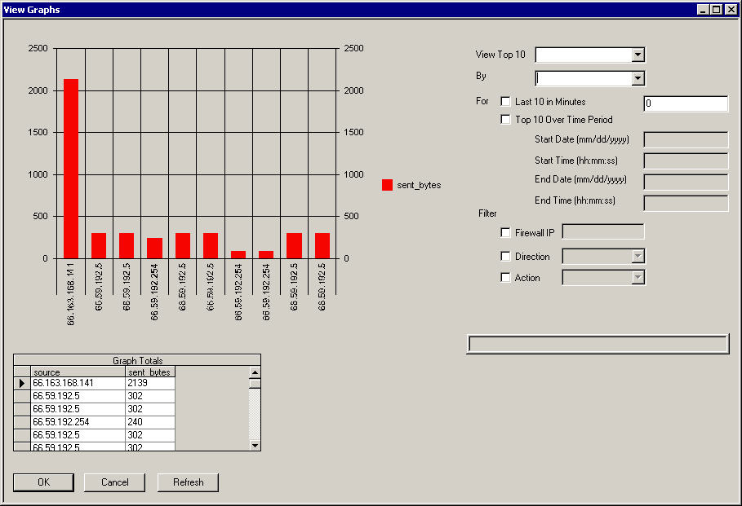

View Top 10: Use this filter to select if you want to view the top 10 source, destination or service.
By: Use this filter to select if you want to see the top 10 source, destination or service by sent bytes, received bytes, total bytes or connections.
For: Use this filter to select the time frame. You can either select the last 10 in minutes or by a specific period of time.
Filter Firewall IP: Use this filter if you only want to see the data from a specific firewall.
Filter Direction: Use this filter if you only want to see data going in a specific direction.
Filter Action: Use this filter if you only want to see data that was allowed or denied.
View Top 10 Table command (View menu)

Lets you view the top 10 in table format. The top 10 can be defined by using the filters.
The results will be displayed in a graph. When you have selected the desired filters, click on the Refresh button to display the results.

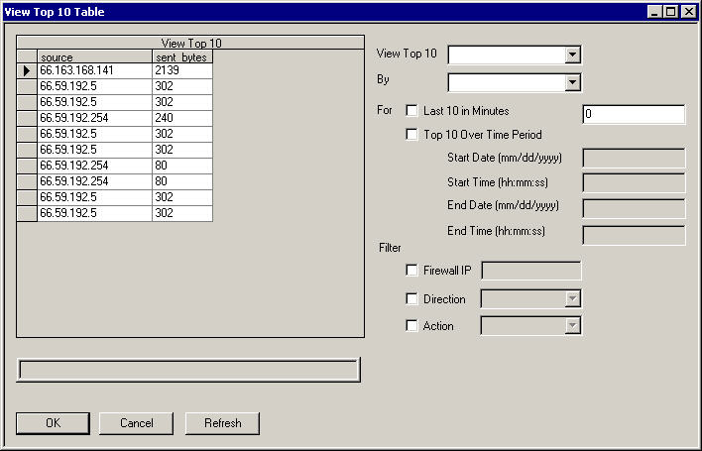

View Top 10: Use this filter to select if you want to view the top 10 source, destination or service.
By: Use this filter to select if you want to see the top 10 source, destination or service by sent bytes, received bytes, total bytes or connections.
For: Use this filter to select the time frame. You can either select the last 10 in minutes or by a specific period of time.
Filter Firewall IP: Use this filter if you only want to see the data from a specific firewall.
Filter Direction: Use this filter if you only want to see data going in a specific direction.
Filter Action: Use this filter if you only want to see data that was allowed or denied.
Help About command (Help menu)

Use this command to view the current license status and version of the Security Logger application..

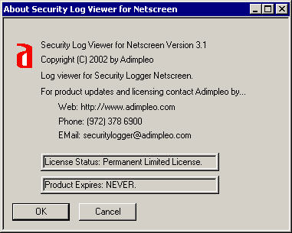
Update License command (Help menu)

Use this command to update the license of the Security Log Viewer application. Please see the Help->About command for information on contacting Adimpleo for an updated license.

